Procurement Management Plan
Date: 06/01/2020

Prepared by: Sai Naveen Bhargava Gajavalli

Project Name: Mabel Cook Recruitment and Visitors Center.
Guidelines on Types of Contracts:

The three basic types of contracts are:

- Fixed Price Contracts:

Cost reimbursable Cost reimbursable contracts require payment based on real costs of sales, as well as a charge or reward to meet or exceed project targets. Hence the buyer faces the greatest risk of costs.

- Cost Reimbursable Contracts:

Fixed price contracts fixed price contracts require a fixed price for the commodity set and are used when the commodity is well specified. Hence the seller bears a higher cost risk burden than the buyer.

- Time and Material Contracts:

- Time and material contracts are a combination of both fixed price and cost reimbursable contracts and is implemented for the small scale projects.
- These contracts may be priced per hour or per item, but they do not determine the total number of hours or items. T&M contracts are also used to raise staff, to recruit experts and to provide external support where a specific description of work cannot be speedily administered.

Standard procurement documents or templates:

Types of Procurement Documents:

- Request For Proposal:

A proposal request is an early stage in a procurement process which invites suppliers to send a proposal on a specific product or service, often through a bidding process.

- Request for information:

A request for information is a proposal received from a potential seller or service provider to assess the goods and services are potentially available on the marketplace to satisfy the needs of a buyer and to know a seller's ability in terms of the seller's offerings and strengths.

- Request for quotation:

A quotation request (RFQ) is used where no negotiation with bidders is needed (mainly where product or service requirements are already known) and when price is the main or only factor in selecting the effective bidder.

- Solicitations:

These are invitations of bids, requests for quotations and proposals. These may serve as a binding contract.

- Offers:

This form of procurement documents are bids, deals and quotations offered to prospective customers by potential suppliers.

- Contracts:

Contracts apply to final customer-supplier deals signed.

- Amendments:

This applies to all updates to solicitations, proposals and contracts. Amendments tend to be in a written text format.

Guidelines for creating procurement documents:

Procurement is the purchase of goods and services at the best possible price to satisfy the demand of a purchaser in terms of quantity, quality, dimensions and location. The procurement process in the work of corporations follows the steps below:

- Information Gathering:

A potential customer first seeks out suppliers, who meet the product requirements.

- Supplier Contact :

When identifying a prospective supplier, the customer requests quotations, offers, information and tender. This can be done by advertising, or direct contact with the supplier.

- Background Review:

The customer also checks references for the services in question and can also find examples of the services or perform trials.
- Negotiation:

Negotiations are conducted with respect to size, quality and customization choices. The contract is concluded for the purchase of the products or services.

- Fulfilment:

The ordered goods or services are shipped and delivered according to the signed contract. Payment is done at this point too. Additional training or product implementation can be offered as well.

- Renewal:

If the products or services are consumed or disposed of, and the contract has expired, it is appropriate to reorder the product or service. Now the customer determines whether to stick with the same supplier or to search for a new supplier.

Roles and responsibilities:

Name and Signature | Role | Position | Contact Information
Ravi Teja Pagidoju  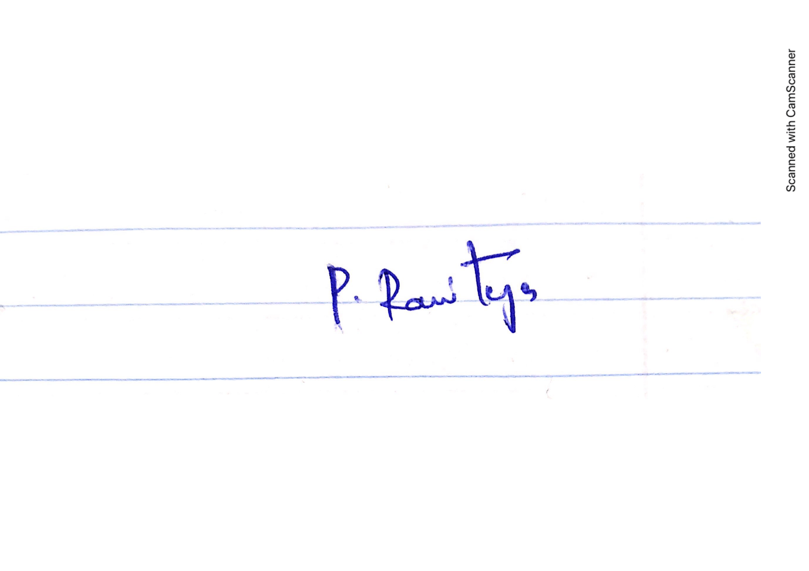 | Project Manager | Manager | S538296@nwmissouri.edu  +1 314-736-8586
Bhavya Deepthi Gorrepati  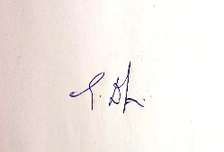 | Team Lead | Lead | S536778@nwmissouri.edu +1 660-528-0896
Sai Naveen Bhargava Gajavalli  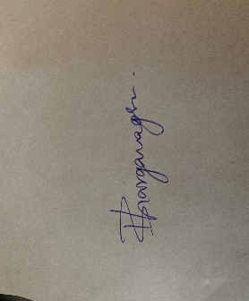 | Team Member | Developer | S536975@nwmissouri.edu  +1 660-528-0748
Pruthvi Naskanti  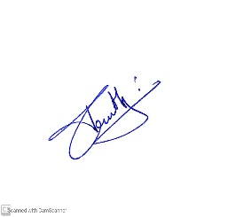 | Team Member | UI Developer | S538094@nwmissouri.edu  +1 913-424-0864
Manisha Mengani  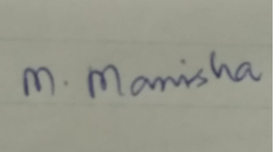 | Team Member | Tester | S537360@nwmissouri.edu  +1 660-528-0928

